Backend Architecture

Reference: https://dev.to/mashrulhaque/how-to-design-a-maintainable-net-solution-structure-for-growing-teams-284n
In my research, I got to a finding that most suitable architecture is as followed:
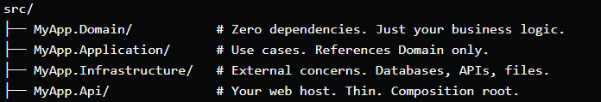

We will divide backend in to 4 directories domain, application, Infrastructure and API.
PharmaTrack.Domain: The Domain project contains the core business model and rules.
PharmaTrack.Application: The Application project contains use cases and application-specific business orchestration.
PharmaTrack.Interfrastructure: Infrastructure contains implementations that interact with external systems. For this project that primarily means SQL Server/EF Core, authentication infrastructure, repositories, etc.
PharmaTrack.Api: The API project is the web host and composition root. Controllers should remain thin: receive HTTP requests, validate the request boundary, call an application use case, and return the appropriate HTTP response.

How each Layer Communicate:

PharmaTrack.Api
↓
PharmaTrack.Application
↓
PharmaTrack.Domain
↑
PharmaTrack.Infrastructure

